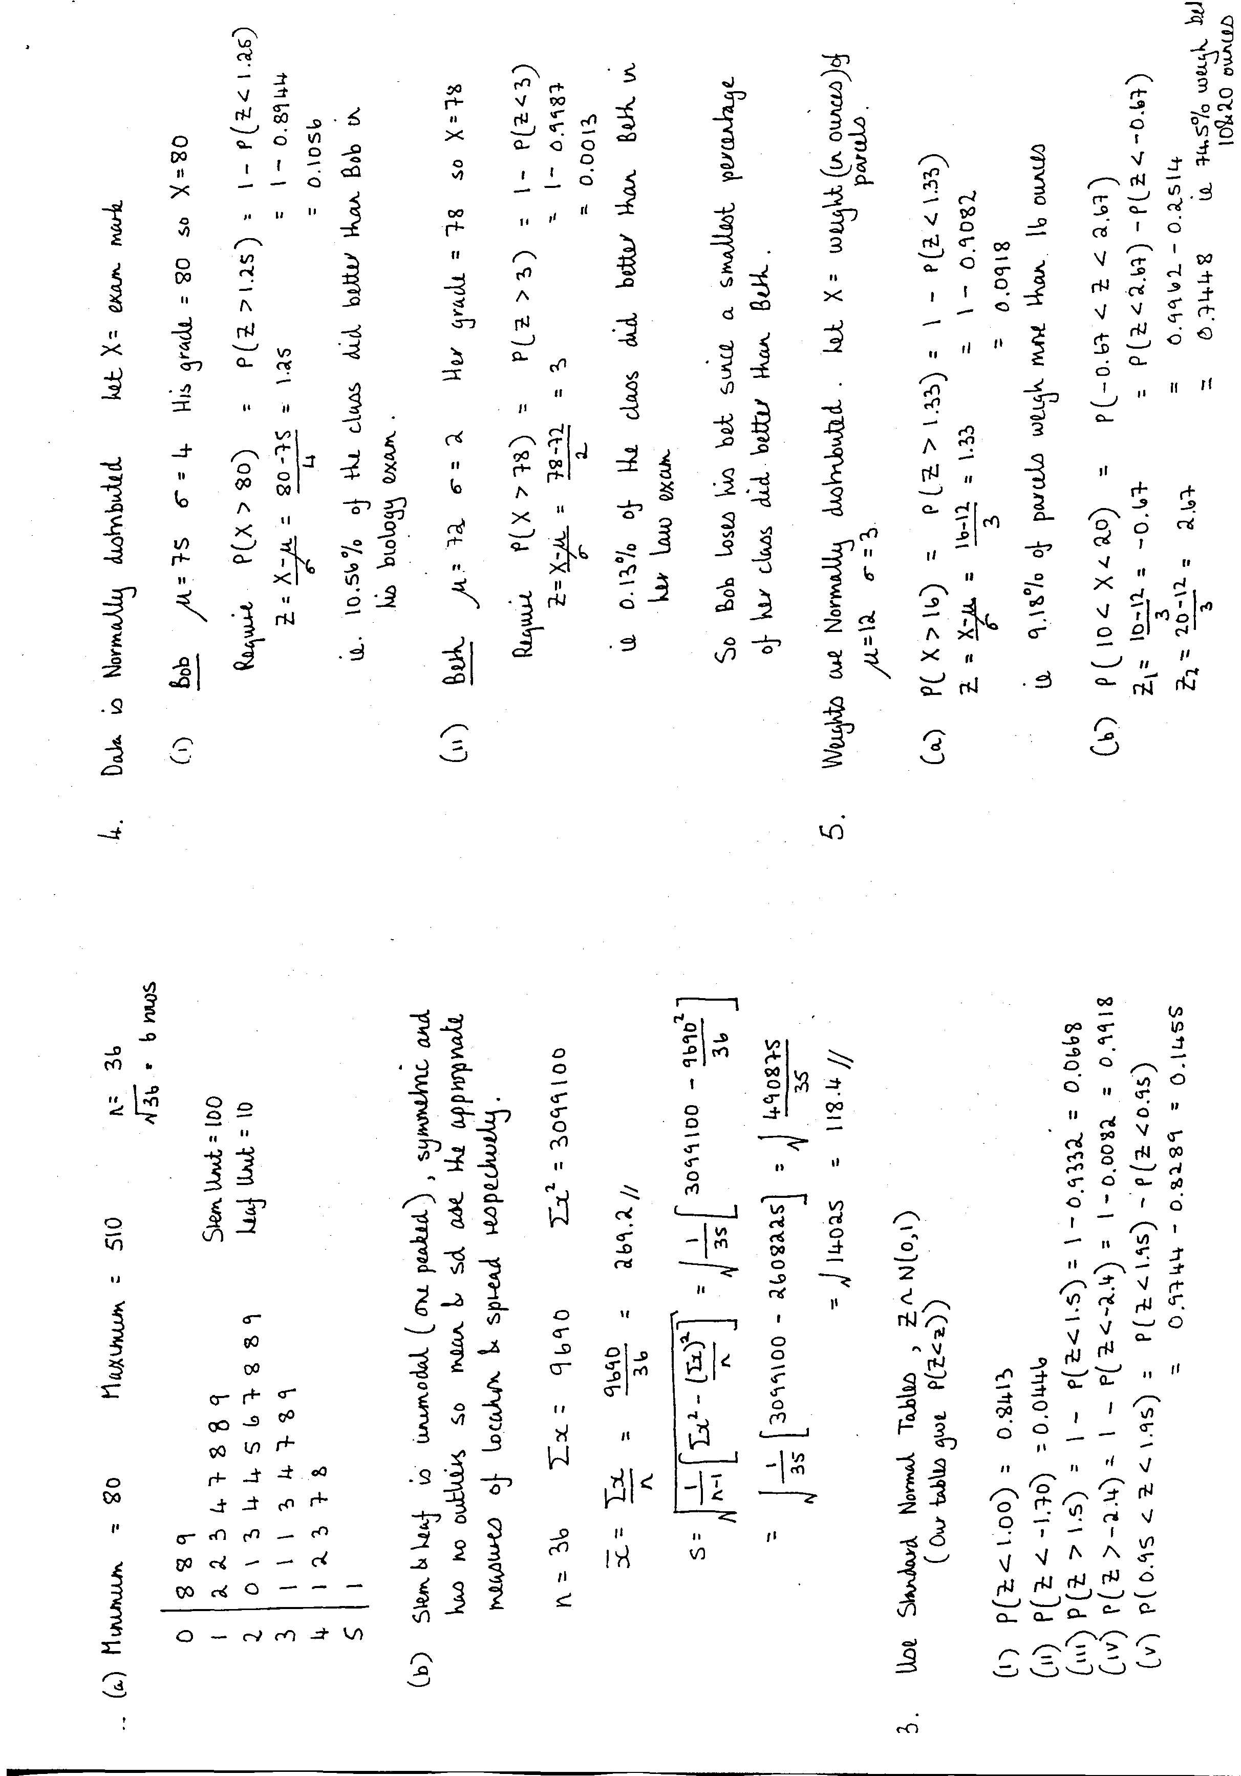

**Q3**

**Q2**

**Q1**

**MATU9D2 : Practical Statistics Spring 2016**

**Solutions to Weekly Assignment 2**

